FreeBSD 11.1-RELEASE Installation Instructions

The FreeBSD Project
Copyright Â© 2017 The FreeBSD Documentation Project
FreeBSD is a registered trademark of the FreeBSD Foundation.
Intel, Celeron, Centrino, Core, EtherExpress, i386, i486, Itanium, Pentium, and Xeon are trademarks or registered trademarks of Intel Corporation or its subsidiaries in the United States and other countries.
SPARC, SPARC64, and UltraSPARC are trademarks of SPARC International, Inc in the United States and other countries. SPARC International, Inc owns all of the SPARC trademarks and under licensing agreements allows the proper use of these trademarks by its members.
Many of the designations used by manufacturers and sellers to distinguish their products are claimed as trademarks. Where those designations appear in this document, and the FreeBSD Project was aware of the trademark claim, the designations have been followed by the “™” or the “Â®” symbol.
Last modified on 2017-07-24 19:18:01Z by gjb.
Abstract
This article gives some brief instructions on installing FreeBSD 11.1-RELEASE and upgrading the systems running earlier releases.

Table of Contents
1. Installing FreeBSD
2. Upgrading FreeBSD
2.1. Upgrading from Source
2.2. Upgrading Using “FreeBSD Update”

1.Â Installing FreeBSD
The Installing FreeBSD chapter of the FreeBSD Handbook provides more in-depth information about the installation program itself, including a guided walk-through with screenshots.

2.Â Upgrading FreeBSD
If you are upgrading from a previous release of FreeBSD, please read upgrading section in the Release Notes for notable incompatibilities carefully.

2.1.Â Upgrading from Source
The procedure for doing a source code based update is described in and .
For SVN use the releng/11.1 branch which will be where any upcoming Security Advisories or Errata Notices will be applied.

2.2.Â Upgrading Using “FreeBSD Update”
The freebsd-update(8) utility supports binary upgrades of i386 and amd64 systems running earlier FreeBSD releases. Systems running 10.3-RELEASE, 11.0-RELEASE, or 11.1-RC[123] can upgrade as follows:
# freebsd-update fetch
# freebsd-update install
Now the freebsd-update(8) utility can fetch bits belonging to 11.1-RELEASE. During this process freebsd-update(8) will ask for help in merging configuration files.
# freebsd-update upgrade -r 11.1-RELEASE
# freebsd-update install
The system must now be rebooted with the newly installed kernel before the non-kernel components are updated.
# shutdown -r now
After rebooting, freebsd-update(8) needs to be run again to install the new userland components:
# freebsd-update install
At this point, users of systems being upgraded from earlier FreeBSD releases will be prompted by freebsd-update(8) to rebuild all third-party applications (e.g., ports installed from the ports tree) due to updates in system libraries.
After updating installed third-party applications (and again, only if freebsd-update(8) printed a message indicating that this was necessary), run freebsd-update(8) again so that it can delete the old (no longer used) system libraries:
# freebsd-update install
Finally, reboot into 11.1-RELEASE
# shutdown -r now

Installing FreeBSD
Restructured, reorganized, and parts rewritten by Jim Mock.
Updated for bsdinstall by Gavin Atkinson and Warren Block.
Updated for root-on-ZFS by Allan Jude.
Table of Contents
2.1. Synopsis
2.2. Minimum Hardware Requirements
2.3. Pre-Installation Tasks
2.4. Starting the Installation
2.5. Using bsdinstall
2.6. Allocating Disk Space
2.7. Committing to the Installation
2.8. Post-Installation
2.9. Troubleshooting
2.10. Using the Live CD

2.1. Synopsis
Beginning with FreeBSD 9.0-RELEASE, FreeBSD provides an easy to use, text-based installation program named bsdinstall. This chapter describes how to install FreeBSD using bsdinstall.
In general, the installation instructions in this chapter are written for the i386™ and AMD64 architectures. Where applicable, instructions specific to other platforms will be listed. There may be minor differences between the installer and what is shown here, so use this chapter as a general guide rather than as a set of literal instructions.

Note:
Users who prefer to install FreeBSD using a graphical installer may be interested in pc-sysinstall, the installer used by the TrueOS Project. It can be used to install either a graphical desktop (TrueOS) or a command line version of FreeBSD. Refer to the TrueOS Users Handbook for details (https://www.trueos.org/handbook/trueos.html).
After reading this chapter, you will know:
- The minimum hardware requirements and FreeBSD supported architectures.
- How to create the FreeBSD installation media.
- How to start bsdinstall.
- The questions bsdinstall will ask, what they mean, and how to answer them.
- How to troubleshoot a failed installation.
- How to access a live version of FreeBSD before committing to an installation.
Before reading this chapter, you should:
- Read the supported hardware list that shipped with the version of FreeBSD to be installed and verify that the system's hardware is supported.

Minimum Hardware Requirements
The hardware requirements to install FreeBSD vary by architecture. Hardware architectures and devices supported by a FreeBSD release are listed on the FreeBSD Release Information page. The FreeBSD download page also has recommendations for choosing the correct image for different architectures.
A FreeBSD installation requires a minimum of 96 MB of RAM and 1.5 GB of free hard drive space. However, such small amounts of memory and disk space are really only suitable for custom applications like embedded appliances. General-purpose desktop systems need more resources. 2-4 GB RAM and at least 8 GB hard drive space is a good starting point.
These are the processor requirements for each architecture:
amd64
This is the most common desktop and laptop processor type, used in most modern systems. Intel® calls it Intel64. Other manufacturers sometimes call it x86-64.
Examples of amd64 compatible processors include: AMD Athlon™64, AMD Opteron™, multi-core Intel® Xeon™, and Intel® Core™ 2 and later processors.
i386
Older desktops and laptops often use this 32-bit, x86 architecture.
Almost all i386-compatible processors with a floating point unit are supported. All Intel® processors 486 or higher are supported.
FreeBSD will take advantage of Physical Address Extensions (PAE) support on CPUs with this feature. A kernel with the PAE feature enabled will detect memory above 4 GB and allow it to be used by the system. However, using PAE places constraints on device drivers and other features of FreeBSD. Refer to pae(4) for details.
ia64
Currently supported processors are the Itanium® and the Itanium® 2. Supported chipsets include the HP zx1, Intel® 460GX, and Intel® E8870. Both Uniprocessor (UP) and Symmetric Multi-processor (SMP) configurations are supported.
pc98
NEC PC-9801/9821 series with almost all i386-compatible processors, including 80486, Pentium®, Pentium® Pro, and Pentium® II, are all supported. All i386-compatible processors by AMD, Cyrix, IBM, and IDT are also supported. EPSON PC-386/486/586 series, which are compatible with NEC PC-9801 series, are supported. The NEC FC-9801/9821 and NEC SV-98 series should be supported.
High-resolution mode is not supported. NEC PC-98XA/XL/RL/XL^2, and NEC PC-H98 series are supported in normal (PC-9801 compatible) mode only. The SMP-related features of FreeBSD are not supported. The New Extend Standard Architecture (NESA) bus used in the PC-H98, SV-H98, and FC-H98 series, is not supported.
powerpc
All New World ROM Apple® Mac® systems with built-in USB are supported. SMP is supported on machines with multiple CPUs.
A 32-bit kernel can only use the first 2 GB of RAM.
sparc64
Systems supported by FreeBSD/sparc64 are listed at the FreeBSD/sparc64 Project.
SMP is supported on all systems with more than 1 processor. A dedicated disk is required as it is not possible to share a disk with another operating system at this time.

Pre-Installation Tasks
Once it has been determined that the system meets the minimum hardware requirements for installing FreeBSD, the installation file should be downloaded and the installation media prepared. Before doing this, check that the system is ready for an installation by verifying the items in this checklist:
- Back Up Important Data
Before installing any operating system, always backup all important data first. Do not store the backup on the system being installed. Instead, save the data to a removable disk such as a USB drive, another system on the network, or an online backup service. Test the backup before starting the installation to make sure it contains all of the needed files. Once the installer formats the system's disk, all data stored on that disk will be lost.
- Decide Where to Install FreeBSD
If FreeBSD will be the only operating system installed, this step can be skipped. But if FreeBSD will share the disk with another operating system, decide which disk or partition will be used for FreeBSD.
In the i386 and amd64 architectures, disks can be divided into multiple partitions using one of two partitioning schemes. A traditional Master Boot Record (MBR) holds a partition table defining up to four primary partitions. For historical reasons, FreeBSD calls these primary partition slices. One of these primary partitions can be made into an extended partition containing multiple logical partitions. The GUID Partition Table (GPT) is a newer and simpler method of partitioning a disk. Common GPT implementations allow up to 128 partitions per disk, eliminating the need for logical partitions.

Warning:
Some older operating systems, like Windows® XP, are not compatible with the GPT partition scheme. If FreeBSD will be sharing a disk with such an operating system, MBR partitioning is required.
The FreeBSD boot loader requires either a primary or GPT partition. If all of the primary or GPT partitions are already in use, one must be freed for FreeBSD. To create a partition without deleting existing data, use a partition resizing tool to shrink an existing partition and create a new partition using the freed space.
A variety of free and commercial partition resizing tools are listed at http://en.wikipedia.org/wiki/List_of_disk_partitioning_software. GParted Live (http://gparted.sourceforge.net/livecd.php) is a free live CD which includes the GParted partition editor. GParted is also included with many other Linux live CD distributions.

Warning:
When used properly, disk shrinking utilities can safely create space for creating a new partition. Since the possibility of selecting the wrong partition exists, always backup any important data and verify the integrity of the backup before modifying disk partitions.
Disk partitions containing different operating systems make it possible to install multiple operating systems on one computer. An alternative is to use virtualization (Chapter 21, Virtualization) which allows multiple operating systems to run at the same time without modifying any disk partitions.
- Collect Network Information
Some FreeBSD installation methods require a network connection in order to download the installation files. After any installation, the installer will offer to setup the system's network interfaces.
If the network has a DHCP server, it can be used to provide automatic network configuration. If DHCP is not available, the following network information for the system must be obtained from the local network administrator or Internet service provider:
Required Network Information
  - IP address
  - Subnet mask
  - IP address of default gateway
  - Domain name of the network
  - IP addresses of the network's DNS servers
- Check for FreeBSD Errata
Although the FreeBSD Project strives to ensure that each release of FreeBSD is as stable as possible, bugs occasionally creep into the process. On very rare occasions those bugs affect the installation process. As these problems are discovered and fixed, they are noted in the FreeBSD Errata (https://www.freebsd.org/releases/11.1R/errata.html) on the FreeBSD web site. Check the errata before installing to make sure that there are no problems that might affect the installation.
Information and errata for all the releases can be found on the release information section of the FreeBSD web site (https://www.freebsd.org/releases/index.html).

2.3.1. Prepare the Installation Media
The FreeBSD installer is not an application that can be run from within another operating system. Instead, download a FreeBSD installation file, burn it to the media associated with its file type and size (CD, DVD, or USB), and boot the system to install from the inserted media.
FreeBSD installation files are available at www.freebsd.org/where.html#download. Each installation file's name includes the release version of FreeBSD, the architecture, and the type of file. For example, to install FreeBSD 10.2 on an amd64 system from a DVD, download FreeBSD-10.2-RELEASE-amd64-dvd1.iso, burn this file to a DVD, and boot the system with the DVD inserted.
Installation files are available in several formats. The formats vary depending on computer architecture and media type.
Additional installation files are included for computers that boot with UEFI (Unified Extensible Firmware Interface). The names of these files include the string uefi.
File types:
- -bootonly.iso: This is the smallest installation file as it only contains the installer. A working Internet connection is required during installation as the installer will download the files it needs to complete the FreeBSD installation. This file should be burned to a CD using a CD burning application.
- -disc1.iso: This file contains all of the files needed to install FreeBSD, its source, and the Ports Collection. It should be burned to a CD using a CD burning application.
- -dvd1.iso: This file contains all of the files needed to install FreeBSD, its source, and the Ports Collection. It also contains a set of popular binary packages for installing a window manager and some applications so that a complete system can be installed from media without requiring a connection to the Internet. This file should be burned to a DVD using a DVD burning application.
- -memstick.img: This file contains all of the files needed to install FreeBSD, its source, and the Ports Collection. It should be burned to a USB stick using the instructions below.
- -mini-memstick.img: Like -bootonly.iso, does not include installation files, but downloads them as needed. A working internet connection is required during installation. Write this file to a USB stick as shown in Section 2.3.1.1, “Writing an Image File to USB”.
After downloading the image file, download CHECKSUM.SHA256 from the same directory. Calculate a checksum for the image file. FreeBSD provides sha256(1) for this, used as sha256 imagefilename. Other operating systems have similar programs.
Compare the calculated checksum with the one shown in CHECKSUM.SHA256. The checksums must match exactly. If the checksums do not match, the image file is corrupt and must be downloaded again.

2.3.1.1. Writing an Image File to USB
The *.img file is an image of the complete contents of a memory stick. It cannot be copied to the target device as a file. Several applications are available for writing the *.img to a USB stick. This section describes two of these utilities.

Important:
Before proceeding, back up any important data on the USB stick. This procedure will erase the existing data on the stick.
Procedure 2.1. Using dd to Write the Image

Warning:
This example uses /dev/da0 as the target device where the image will be written. Be very careful that the correct device is used as this command will destroy the existing data on the specified target device.
- The dd(1) command-line utility is available on BSD, Linux®, and Mac OS® systems. To burn the image using dd, insert the USB stick and determine its device name. Then, specify the name of the downloaded installation file and the device name for the USB stick. This example burns the amd64 installation image to the first USB device on an existing FreeBSD system.
# dd if=FreeBSD-10.2-RELEASE-amd64-memstick.img of=/dev/da0 bs=1M conv=sync
If this command fails, verify that the USB stick is not mounted and that the device name is for the disk, not a partition. Some operating systems might require this command to be run with sudo(8). Systems like Linux® might buffer writes. To force all writes to complete, use sync(8).
Procedure 2.2. Using Windows® to Write the Image

Warning:
Be sure to give the correct drive letter as the existing data on the specified drive will be overwritten and destroyed.
- Obtaining Image Writer for Windows®
Image Writer for Windows® is a free application that can correctly write an image file to a memory stick. Download it from https://sourceforge.net/projects/win32diskimager/ and extract it into a folder.
- Writing the Image with Image Writer
Double-click the Win32DiskImager icon to start the program. Verify that the drive letter shown under Device is the drive with the memory stick. Click the folder icon and select the image to be written to the memory stick. Click [ Save ] to accept the image file name. Verify that everything is correct, and that no folders on the memory stick are open in other windows. When everything is ready, click [ Write ] to write the image file to the memory stick.
You are now ready to start installing FreeBSD.

Starting the Installation

Important:
By default, the installation will not make any changes to the disk(s) before the following message:
Your changes will now be written to disk. If you
have chosen to overwrite existing data, it will
be PERMANENTLY ERASED. Are you sure you want to
commit your changes?
The install can be exited at any time prior to this warning. If there is a concern that something is incorrectly configured, just turn the computer off before this point and no changes will be made to the system's disks.
This section describes how to boot the system from the installation media which was prepared using the instructions in Section 2.3.1, “Prepare the Installation Media”. When using a bootable USB stick, plug in the USB stick before turning on the computer. When booting from CD or DVD, turn on the computer and insert the media at the first opportunity. How to configure the system to boot from the inserted media depends upon the architecture.

2.4.1. Booting on i386™ and amd64
These architectures provide a BIOS menu for selecting the boot device. Depending upon the installation media being used, select the CD/DVD or USB device as the first boot device. Most systems also provide a key for selecting the boot device during startup without having to enter the BIOS. Typically, the key is either F10, F11, F12, or Escape.
If the computer loads the existing operating system instead of the FreeBSD installer, then either:
- The installation media was not inserted early enough in the boot process. Leave the media inserted and try restarting the computer.
- The BIOS changes were incorrect or not saved. Double-check that the right boot device is selected as the first boot device.
- This system is too old to support booting from the chosen media. In this case, the Plop Boot Manager (http://www.plop.at/en/bootmanagers.html) can be used to boot the system from the selected media.

2.4.2. Booting on PowerPC®
On most machines, holding C on the keyboard during boot will boot from the CD. Otherwise, hold Command+Option+O+F, or Windows+Alt+O+F on non-Apple® keyboards. At the 0 > prompt, enter
boot cd:,\ppc\loader cd:0

2.4.3. Booting on SPARC64®
Most SPARC64® systems are set up to boot automatically from disk. To install FreeBSD from a CD requires a break into the PROM.
To do this, reboot the system and wait until the boot message appears. The message depends on the model, but should look something like this:
Sun Blade 100 (UltraSPARC-IIe), Keyboard Present
Copyright 1998-2001 Sun Microsystems, Inc. All rights reserved.
OpenBoot 4.2, 128 MB memory installed, Serial #51090132.
Ethernet address 0:3:ba:b:92:d4, Host ID: 830b92d4.
If the system proceeds to boot from disk at this point, press L1+A or Stop+A on the keyboard, or send a BREAK over the serial console. When using tip or cu, ~# will issue a BREAK. The PROM prompt will be ok on systems with one CPU and ok {0} on SMP systems, where the digit indicates the number of the active CPU.
At this point, place the CD into the drive and type boot cdrom from the PROM prompt.

2.4.4. FreeBSD Boot Menu
Once the system boots from the installation media, a menu similar to the following will be displayed:
Figure 2.1. FreeBSD Boot Loader Menu
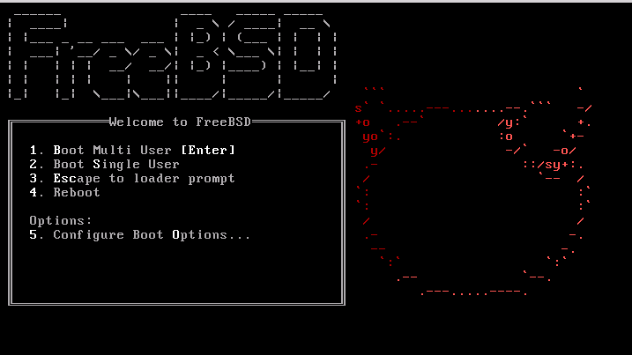

By default, the menu will wait ten seconds for user input before booting into the FreeBSD installer or, if FreeBSD is already installed, before booting into FreeBSD. To pause the boot timer in order to review the selections, press Space. To select an option, press its highlighted number, character, or key. The following options are available.
- Boot Multi User: This will continue the FreeBSD boot process. If the boot timer has been paused, press 1, upper- or lower-case B, or Enter.
- Boot Single User: This mode can be used to fix an existing FreeBSD installation as described in Section 12.2.4.1, “Single-User Mode”. Press 2 or the upper- or lower-case S to enter this mode.
- Escape to loader prompt: This will boot the system into a repair prompt that contains a limited number of low-level commands. This prompt is described in Section 12.2.3, “Stage Three”. Press 3 or Esc to boot into this prompt.
- Reboot: Reboots the system.
- Configure Boot Options: Opens the menu shown in, and described under, Figure 2.2, “FreeBSD Boot Options Menu”.
Figure 2.2. FreeBSD Boot Options Menu
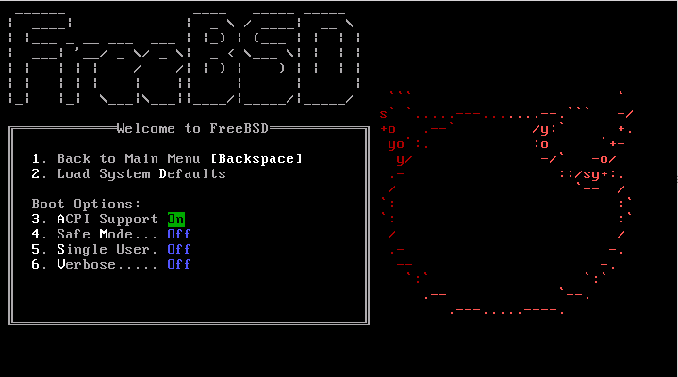

The boot options menu is divided into two sections. The first section can be used to either return to the main boot menu or to reset any toggled options back to their defaults.
The next section is used to toggle the available options to On or Off by pressing the option's highlighted number or character. The system will always boot using the settings for these options until they are modified. Several options can be toggled using this menu:
- ACPI Support: If the system hangs during boot, try toggling this option to Off.
- Safe Mode: If the system still hangs during boot even with ACPI Support set to Off, try setting this option to On.
- Single User: Toggle this option to On to fix an existing FreeBSD installation as described in Section 12.2.4.1, “Single-User Mode”. Once the problem is fixed, set it back to Off.
- Verbose: Toggle this option to On to see more detailed messages during the boot process. This can be useful when troubleshooting a piece of hardware.
After making the needed selections, press 1 or Backspace to return to the main boot menu, then press Enter to continue booting into FreeBSD. A series of boot messages will appear as FreeBSD carries out its hardware device probes and loads the installation program. Once the boot is complete, the welcome menu shown in Figure 2.3, “Welcome Menu” will be displayed.
Figure 2.3. Welcome Menu
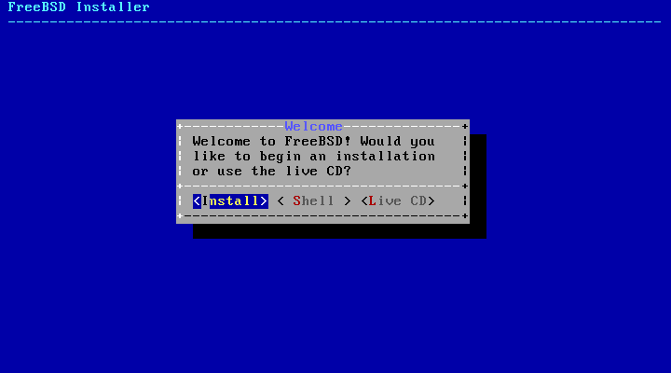

Press Enter to select the default of [ Install ] to enter the installer. The rest of this chapter describes how to use this installer. Otherwise, use the right or left arrows or the colorized letter to select the desired menu item. The [ Shell ] can be used to access a FreeBSD shell in order to use command line utilities to prepare the disks before installation. The [ Live CD ] option can be used to try out FreeBSD before installing it. The live version is described in Section 2.10, “Using the Live CD”.

Tip:
To review the boot messages, including the hardware device probe, press the upper- or lower-case S and then Enter to access a shell. At the shell prompt, type more /var/run/dmesg.boot and use the space bar to scroll through the messages. When finished, type exit to return to the welcome menu.

Using bsdinstall
This section shows the order of the bsdinstall menus and the type of information that will be asked before the system is installed. Use the arrow keys to highlight a menu option, then Space to select or deselect that menu item. When finished, press Enter to save the selection and move onto the next screen.

2.5.1. Selecting the Keymap Menu
Depending on the system console being used, bsdinstall may initially display the menu shown in Figure 2.4, “Keymap Selection”.
Figure 2.4. Keymap Selection
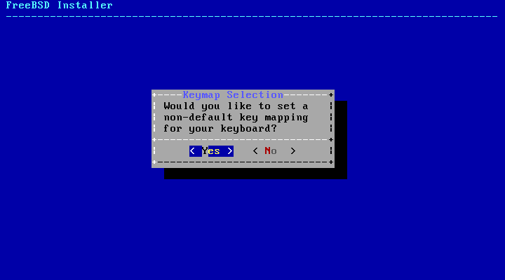

To configure the keyboard layout, press Enter with [ YES ] selected, which will display the menu shown in Figure 2.5, “Selecting Keyboard Menu”. To instead use the default layout, use the arrow key to select [ NO ] and press Enter to skip this menu screen.
Figure 2.5. Selecting Keyboard Menu
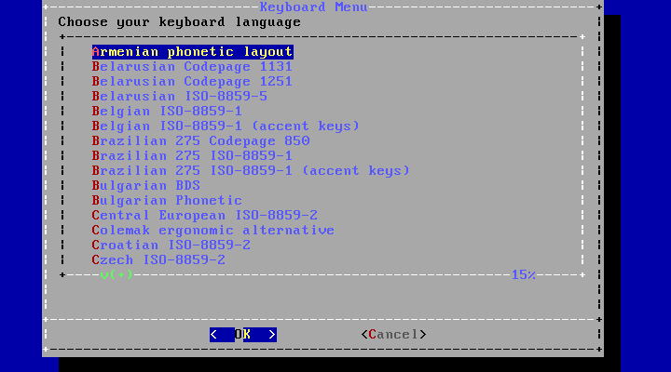

When configuring the keyboard layout, use the up and down arrows to select the keymap that most closely represents the mapping of the keyboard attached to the system. Press Enter to save the selection.

Note:
Pressing Esc will exit this menu and use the default keymap. If the choice of keymap is not clear, United States of America ISO-8859-1 is also a safe option.
In FreeBSD 10.0-RELEASE and later, this menu has been enhanced. The full selection of keymaps is shown, with the default preselected. In addition, when selecting a different keymap, a dialog is displayed that allows the user to try the keymap and ensure it is correct before proceeding.
Figure 2.6. Enhanced Keymap Menu
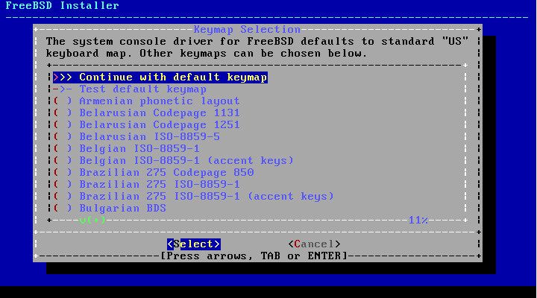

2.5.2. Setting the Hostname
The next bsdinstall menu is used to set the hostname for the newly installed system.
Figure 2.7. Setting the Hostname
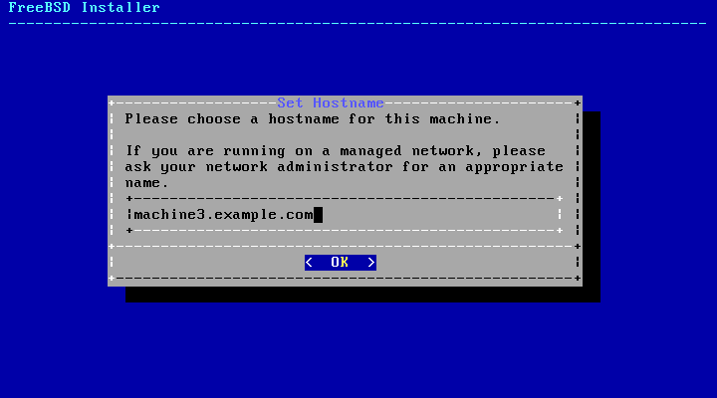

Type in a hostname that is unique for the network. It should be a fully-qualified hostname, such as machine3.example.com.

2.5.3. Selecting Components to Install
Next, bsdinstall will prompt to select optional components to install.
Figure 2.8. Selecting Components to Install
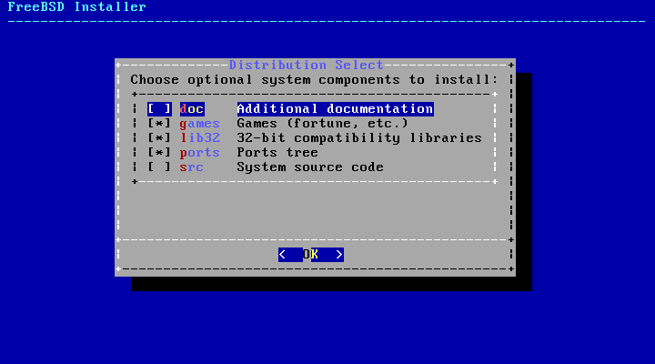

Deciding which components to install will depend largely on the intended use of the system and the amount of disk space available. The FreeBSD kernel and userland, collectively known as the base system, are always installed. Depending on the architecture, some of these components may not appear:
- doc - Additional documentation, mostly of historical interest, to install into /usr/share/doc. The documentation provided by the FreeBSD Documentation Project may be installed later using the instructions in Section 23.3, “Updating the Documentation Set”.
- games - Several traditional BSD games, including fortune, rot13, and others.
- lib32 - Compatibility libraries for running 32-bit applications on a 64-bit version of FreeBSD.
- ports - The FreeBSD Ports Collection is a collection of files which automates the downloading, compiling and installation of third-party software packages. Chapter 4, Installing Applications: Packages and Ports discusses how to use the Ports Collection.

Warning:
The installation program does not check for adequate disk space. Select this option only if sufficient hard disk space is available. The FreeBSD Ports Collection takes up about 500 MB of disk space.
- src - The complete FreeBSD source code for both the kernel and the userland. Although not required for the majority of applications, it may be required to build device drivers, kernel modules, or some applications from the Ports Collection. It is also used for developing FreeBSD itself. The full source tree requires 1 GB of disk space and recompiling the entire FreeBSD system requires an additional 5 GB of space.

2.5.4. Installing from the Network
The menu shown in Figure 2.9, “Installing from the Network” only appears when installing from a -bootonly.iso CD as this installation media does not hold copies of the installation files. Since the installation files must be retrieved over a network connection, this menu indicates that the network interface must be first configured.
Figure 2.9. Installing from the Network
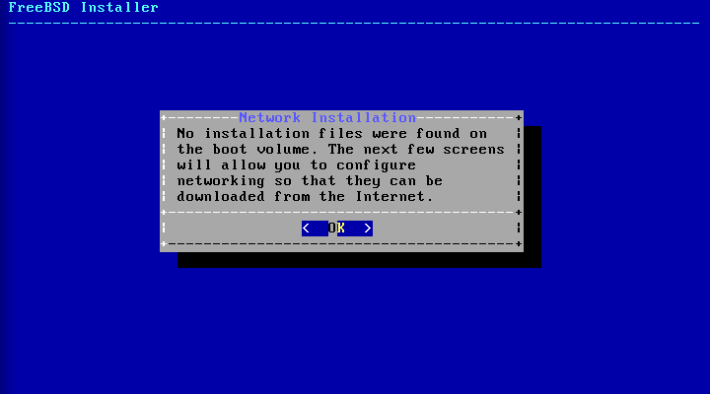

To configure the network connection, press Enter and follow the instructions in Section 2.8.2, “Configuring Network Interfaces”. Once the interface is configured, select a mirror site that is located in the same region of the world as the computer on which FreeBSD is being installed. Files can be retrieved more quickly when the mirror is close to the target computer, reducing installation time.
Figure 2.10. Choosing a Mirror
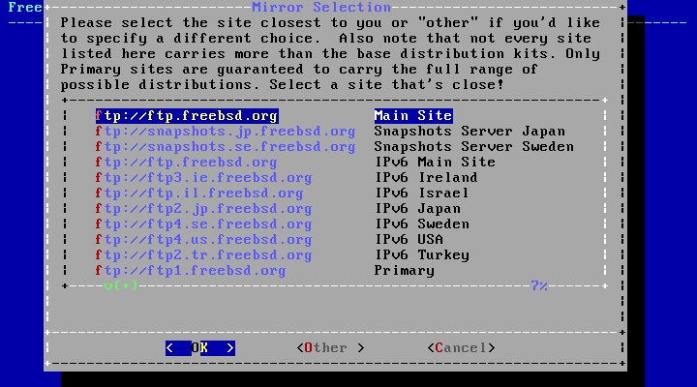

Installation will then continue as if the installation files were located on the local installation media.

Allocating Disk Space
The next menu is used to determine the method for allocating disk space. The options available in the menu depend upon the version of FreeBSD being installed.
Figure 2.11. Partitioning Choices on FreeBSD 9.x
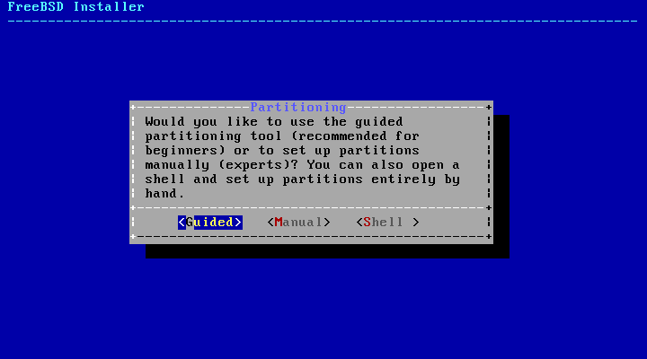

Figure 2.12. Partitioning Choices on FreeBSD 10.x and Higher
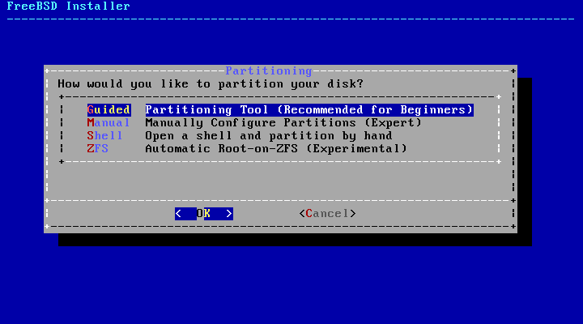

Guided partitioning automatically sets up the disk partitions, Manual partitioning allows advanced users to create customized partitions from menu options, and Shell opens a shell prompt where advanced users can create customized partitions using command-line utilities like gpart(8), fdisk(8), and bsdlabel(8). ZFS partitioning, only available in FreeBSD 10 and later, creates an optionally encrypted root-on-ZFS system with support for boot environments.
This section describes what to consider when laying out the disk partitions. It then demonstrates how to use the different partitioning methods.

2.6.1. Designing the Partition Layout
When laying out file systems, remember that hard drives transfer data faster from the outer tracks to the inner. Thus, smaller and heavier-accessed file systems should be closer to the outside of the drive, while larger partitions like /usr should be placed toward the inner parts of the disk. It is a good idea to create partitions in an order similar to: /, swap, /var, and /usr.
The size of the /var partition reflects the intended machine's usage. This partition is used to hold mailboxes, log files, and printer spools. Mailboxes and log files can grow to unexpected sizes depending on the number of users and how long log files are kept. On average, most users rarely need more than about a gigabyte of free disk space in /var.

Note:
Sometimes, a lot of disk space is required in /var/tmp. When new software is installed, the packaging tools extract a temporary copy of the packages under /var/tmp. Large software packages, like Firefox, Apache OpenOffice or LibreOffice may be tricky to install if there is not enough disk space under /var/tmp.
The /usr partition holds many of the files which support the system, including the FreeBSD Ports Collection and system source code. At least 2 gigabytes of space is recommended for this partition.
When selecting partition sizes, keep the space requirements in mind. Running out of space in one partition while barely using another can be a hassle.
As a rule of thumb, the swap partition should be about double the size of physical memory (RAM). Systems with minimal RAM may perform better with more swap. Configuring too little swap can lead to inefficiencies in the VM page scanning code and might create issues later if more memory is added.
On larger systems with multiple SCSI disks or multiple IDE disks operating on different controllers, it is recommended that swap be configured on each drive, up to four drives. The swap partitions should be approximately the same size. The kernel can handle arbitrary sizes but internal data structures scale to 4 times the largest swap partition. Keeping the swap partitions near the same size will allow the kernel to optimally stripe swap space across disks. Large swap sizes are fine, even if swap is not used much. It might be easier to recover from a runaway program before being forced to reboot.
By properly partitioning a system, fragmentation introduced in the smaller write heavy partitions will not bleed over into the mostly read partitions. Keeping the write loaded partitions closer to the disk's edge will increase I/O performance in the partitions where it occurs the most. While I/O performance in the larger partitions may be needed, shifting them more toward the edge of the disk will not lead to a significant performance improvement over moving /var to the edge.

2.6.2. Guided Partitioning
When this method is selected, a menu will display the available disk(s). If multiple disks are connected, choose the one where FreeBSD is to be installed.
Figure 2.13. Selecting from Multiple Disks
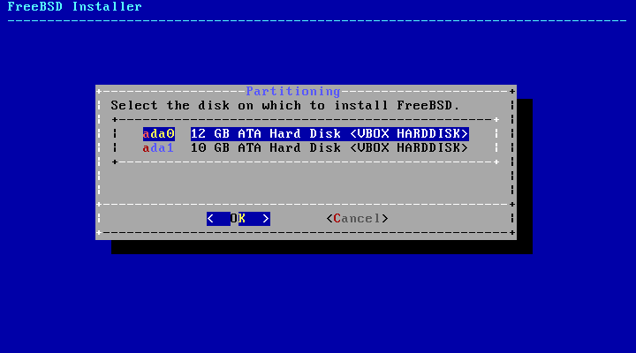

Once the disk is selected, the next menu prompts to install to either the entire disk or to create a partition using free space. If [ Entire Disk ] is chosen, a general partition layout filling the whole disk is automatically created. Selecting [ Partition ] creates a partition layout from the unused space on the disk.
Figure 2.14. Selecting Entire Disk or Partition
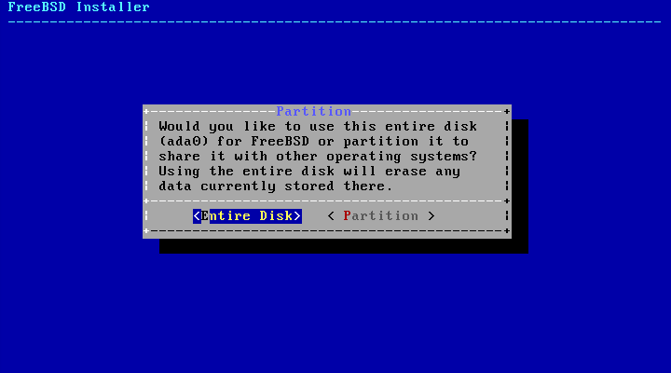

After the partition layout has been created, review it to ensure it meets the needs of the installation. Selecting [ Revert ] will reset the partitions to their original values and pressing [ Auto ] will recreate the automatic FreeBSD partitions. Partitions can also be manually created, modified, or deleted. When the partitioning is correct, select [ Finish ] to continue with the installation.
Figure 2.15. Review Created Partitions
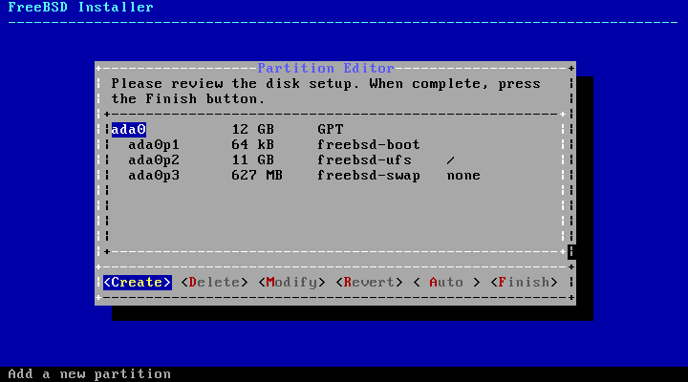

2.6.3. Manual Partitioning
Selecting this method opens the partition editor:
Figure 2.16. Manually Create Partitions
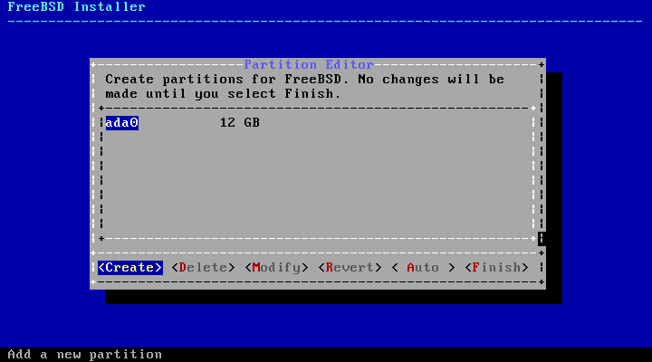

Highlight the installation drive (ada0 in this example) and select [ Create ] to display a menu of available partition schemes:
Figure 2.17. Manually Create Partitions
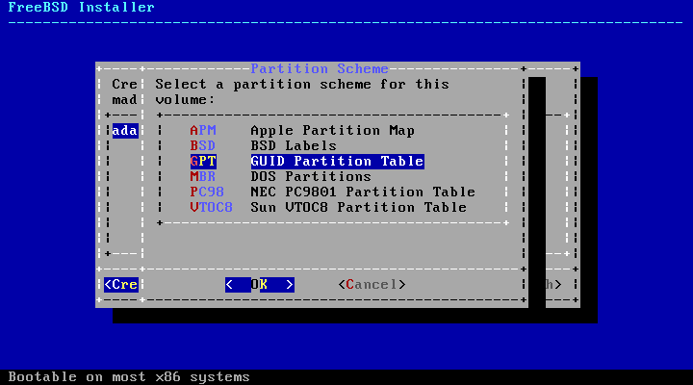

GPT is usually the most appropriate choice for amd64 computers. Older computers that are not compatible with GPT should use MBR. The other partition schemes are generally used for uncommon or older computers.
Table 2.1. Partitioning Schemes
Abbreviation | Description
APM | Apple Partition Map, used by PowerPC®.
BSD | BSD label without an MBR, sometimes called dangerously dedicated mode as non-BSD disk utilities may not recognize it.
GPT | GUID Partition Table (http://en.wikipedia.org/wiki/GUID_Partition_Table).
MBR | Master Boot Record (http://en.wikipedia.org/wiki/Master_boot_record).
PC98 | MBR variant used by NEC PC-98 computers (http://en.wikipedia.org/wiki/Pc9801).
VTOC8 | Volume Table Of Contents used by Sun SPARC64 and UltraSPARC computers.

After the partitioning scheme has been selected and created, select [ Create ] again to create the partitions.
Figure 2.18. Manually Create Partitions
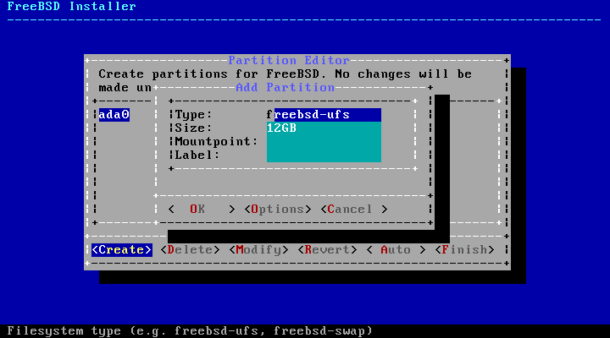

A standard FreeBSD GPT installation uses at least three partitions:
- freebsd-boot - Holds the FreeBSD boot code.
- freebsd-ufs - A FreeBSD UFS file system.
- freebsd-swap - FreeBSD swap space.
Another partition type worth noting is freebsd-zfs, used for partitions that will contain a FreeBSD ZFS file system (Chapter 19, The Z File System (ZFS)). Refer to gpart(8) for descriptions of the available GPT partition types.
Multiple file system partitions can be created and some people prefer a traditional layout with separate partitions for /, /var, /tmp, and /usr. See Example 2.1, “Creating Traditional Split File System Partitions” for an example.
The Size may be entered with common abbreviations: K for kilobytes, M for megabytes, or G for gigabytes.

Tip:
Proper sector alignment provides the best performance, and making partition sizes even multiples of 4K bytes helps to ensure alignment on drives with either 512-byte or 4K-byte sectors. Generally, using partition sizes that are even multiples of 1M or 1G is the easiest way to make sure every partition starts at an even multiple of 4K. There is one exception: the freebsd-boot partition should be no larger than 512K due to current boot code limitations.
A Mountpoint is needed if the partition will contain a file system. If only a single UFS partition will be created, the mountpoint should be /.
The Label is a name by which the partition will be known. Drive names or numbers can change if the drive is connected to a different controller or port, but the partition label does not change. Referring to labels instead of drive names and partition numbers in files like /etc/fstab makes the system more tolerant to hardware changes. GPT labels appear in /dev/gpt/ when a disk is attached. Other partitioning schemes have different label capabilities and their labels appear in different directories in /dev/.

Tip:
Use a unique label on every partition to avoid conflicts from identical labels. A few letters from the computer's name, use, or location can be added to the label. For instance, use labroot or rootfslab for the UFS root partition on the computer named lab.
Example 2.1. Creating Traditional Split File System Partitions
For a traditional partition layout where the /, /var, /tmp, and /usr directories are separate file systems on their own partitions, create a GPT partitioning scheme, then create the partitions as shown. Partition sizes shown are typical for a 20G target disk. If more space is available on the target disk, larger swap or /var partitions may be useful. Labels shown here are prefixed with ex for “example”, but readers should use other unique label values as described above.
By default, FreeBSD's gptboot expects the first UFS partition to be the / partition.
Partition Type | Size | Mountpoint | Label
freebsd-boot | 512K
freebsd-ufs | 2G | / | exrootfs
freebsd-swap | 4G |  | exswap
freebsd-ufs | 2G | /var | exvarfs
freebsd-ufs | 1G | /tmp | extmpfs
freebsd-ufs | accept the default (remainder of the disk) | /usr | exusrfs

After the custom partitions have been created, select [ Finish ] to continue with the installation.

2.6.4. Root-on-ZFS Automatic Partitioning
Support for automatic creation of root-on-ZFS installations was added in FreeBSD 10.0-RELEASE. This partitioning mode only works with whole disks and will erase the contents of the entire disk. The installer will automatically create partitions aligned to 4k boundaries and force ZFS to use 4k sectors. This is safe even with 512 byte sector disks, and has the added benefit of ensuring that pools created on 512 byte disks will be able to have 4k sector disks added in the future, either as additional storage space or as replacements for failed disks. The installer can also optionally employ GELI disk encryption as described in Section 17.12.2, “Disk Encryption with geli”. If encryption is enabled, a 2 GB unencrypted boot pool containing the /boot directory is created. It holds the kernel and other files necessary to boot the system. A swap partition of a user selectable size is also created, and all remaining space is used for the ZFS pool.
The main ZFS configuration menu offers a number of options to control the creation of the pool.
Figure 2.19. ZFS Partitioning Menu
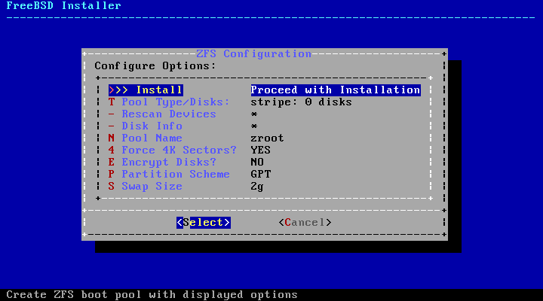

Select T to configure the Pool Type and the disk(s) that will constitute the pool. The automatic ZFS installer currently only supports the creation of a single top level vdev, except in stripe mode. To create more complex pools, use the instructions in Section 2.6.5, “Shell Mode Partitioning” to create the pool. The installer supports the creation of various pool types, including stripe (not recommended, no redundancy), mirror (best performance, least usable space), and RAID-Z 1, 2, and 3 (with the capability to withstand the concurrent failure of 1, 2, and 3 disks, respectively). While selecting the pool type, a tooltip is displayed across the bottom of the screen with advice about the number of required disks, and in the case of RAID-Z, the optimal number of disks for each configuration.
Figure 2.20. ZFS Pool Type
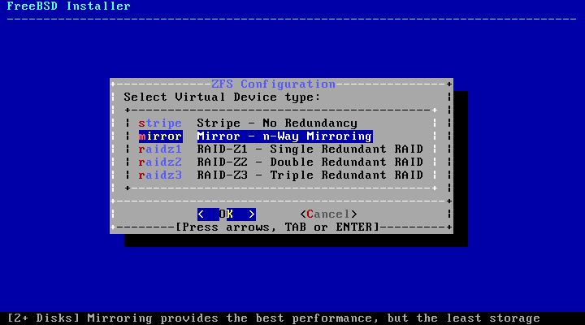

Once a Pool Type has been selected, a list of available disks is displayed, and the user is prompted to select one or more disks to make up the pool. The configuration is then validated, to ensure enough disks are selected. If not, select <Change Selection> to return to the list of disks, or <Cancel> to change the pool type.
Figure 2.21. Disk Selection
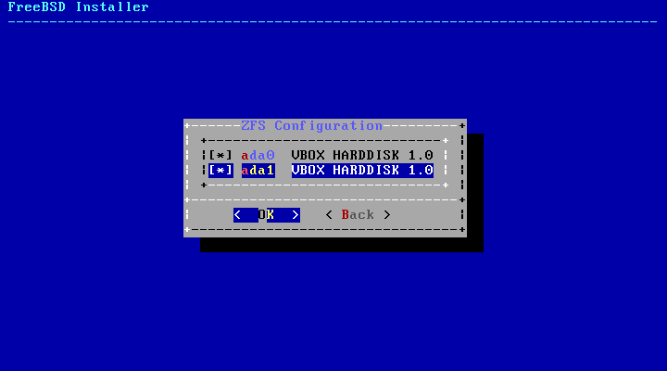

Figure 2.22. Invalid Selection
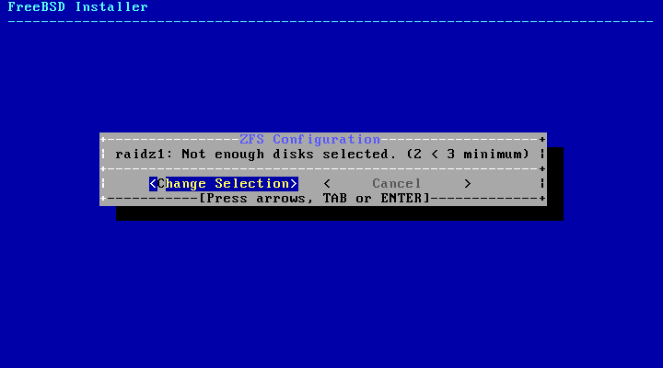

If one or more disks are missing from the list, or if disks were attached after the installer was started, select - Rescan Devices to repopulate the list of available disks. To avoid accidentally erasing the wrong disk, the - Disk Info menu can be used to inspect each disk, including its partition table and various other information such as the device model number and serial number, if available.
Figure 2.23. Analyzing a Disk
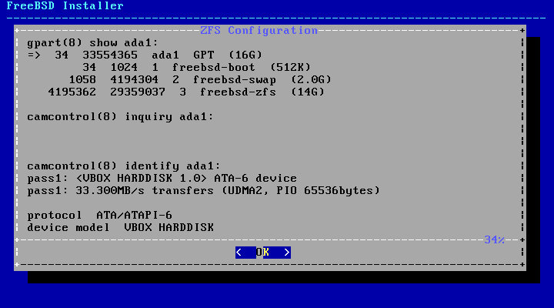

The main ZFS configuration menu also allows the user to enter a pool name, disable forcing 4k sectors, enable or disable encryption, switch between GPT (recommended) and MBR partition table types, and select the amount of swap space. Once all options have been set to the desired values, select the >>> Install option at the top of the menu.
If GELI disk encryption was enabled, the installer will prompt twice for the passphrase to be used to encrypt the disks.
Figure 2.24. Disk Encryption Password
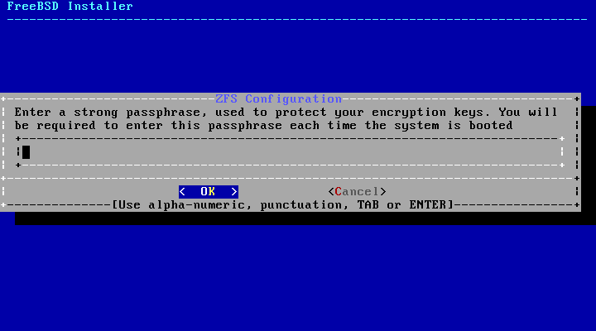

The installer then offers a last chance to cancel before the contents of the selected drives are destroyed to create the ZFS pool.
Figure 2.25. Last Chance
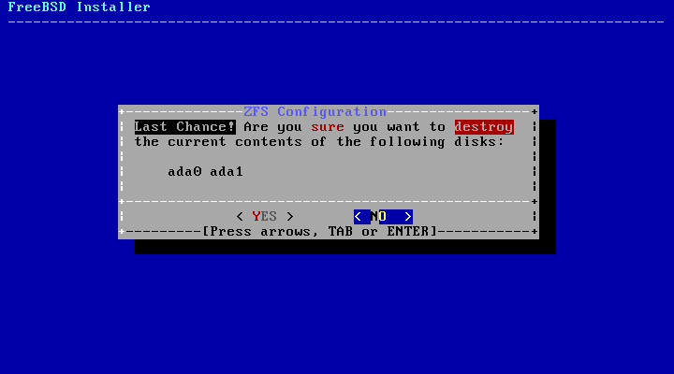

The installation then proceeds normally.

2.6.5. Shell Mode Partitioning
When creating advanced installations, the bsdinstall partitioning menus may not provide the level of flexibility required. Advanced users can select the Shell option from the partitioning menu in order to manually partition the drives, create the file system(s), populate /tmp/bsdinstall_etc/fstab, and mount the file systems under /mnt. Once this is done, type exit to return to bsdinstall and continue the installation.

Committing to the Installation
Once the disks are configured, the next menu provides the last chance to make changes before the selected hard drive(s) are formatted. If changes need to be made, select [ Back ] to return to the main partitioning menu. [ Revert & Exit ] will exit the installer without making any changes to the hard drive.
Figure 2.26. Final Confirmation
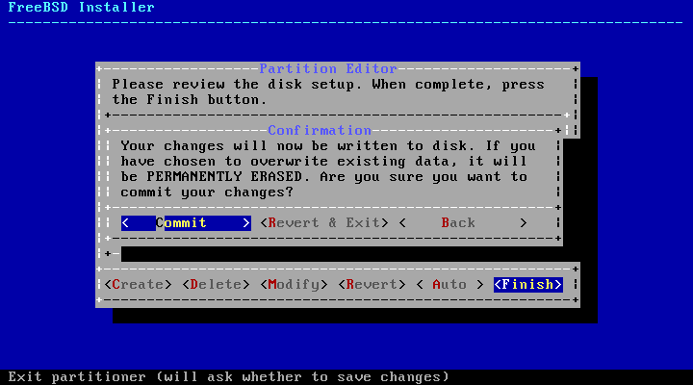

To instead start the actual installation, select [ Commit ] and press Enter.
Installation time will vary depending on the distributions chosen, installation media, and speed of the computer. A series of messages will indicate the progress.
First, the installer formats the selected disk(s) and initializes the partitions. Next, in the case of a bootonly media, it downloads the selected components:
Figure 2.27. Fetching Distribution Files
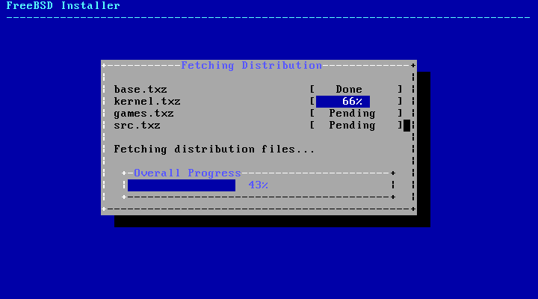

Next, the integrity of the distribution files is verified to ensure they have not been corrupted during download or misread from the installation media:
Figure 2.28. Verifying Distribution Files
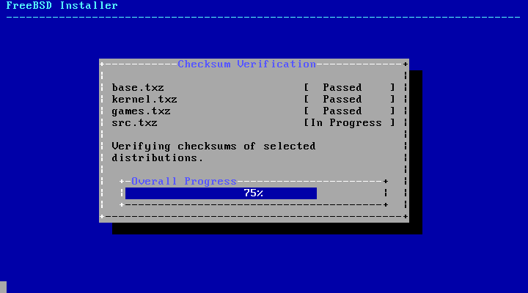

Finally, the verified distribution files are extracted to the disk:
Figure 2.29. Extracting Distribution Files
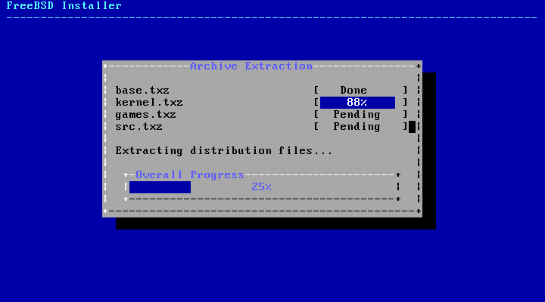

Once all requested distribution files have been extracted, bsdinstall displays the first post-installation configuration screen. The available post-configuration options are described in the next section.

Post-Installation
Once FreeBSD is installed, bsdinstall will prompt to configure several options before booting into the newly installed system. This section describes these configuration options.

Tip:
Once the system has booted, bsdconfig provides a menu-driven method for configuring the system using these and additional options.

2.8.1. Setting the root Password
First, the root password must be set. While entering the password, the characters being typed are not displayed on the screen. After the password has been entered, it must be entered again. This helps prevent typing errors.
Figure 2.30. Setting the root Password
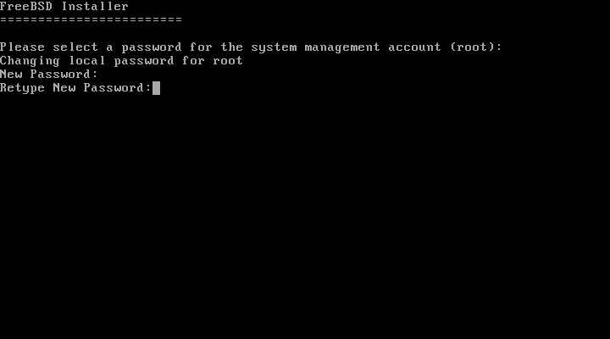

2.8.2. Configuring Network Interfaces
Next, a list of the network interfaces found on the computer is shown. Select the interface to configure.

Note:
The network configuration menus will be skipped if the network was previously configured as part of a bootonly installation.
Figure 2.31. Choose a Network Interface
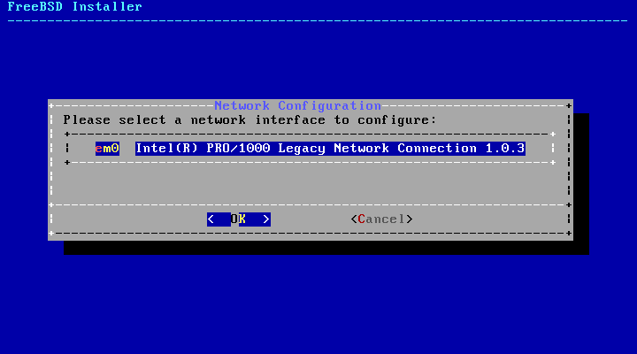

If an Ethernet interface is selected, the installer will skip ahead to the menu shown in Figure 2.35, “Choose IPv4 Networking”. If a wireless network interface is chosen, the system will instead scan for wireless access points:
Figure 2.32. Scanning for Wireless Access Points
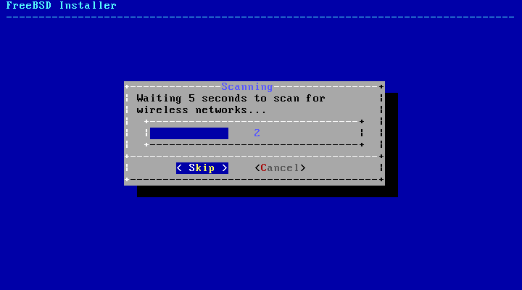

Wireless networks are identified by a Service Set Identifier (SSID), a short, unique name given to each network. SSIDs found during the scan are listed, followed by a description of the encryption types available for that network. If the desired SSID does not appear in the list, select [ Rescan ] to scan again. If the desired network still does not appear, check for problems with antenna connections or try moving the computer closer to the access point. Rescan after each change is made.
Figure 2.33. Choosing a Wireless Network
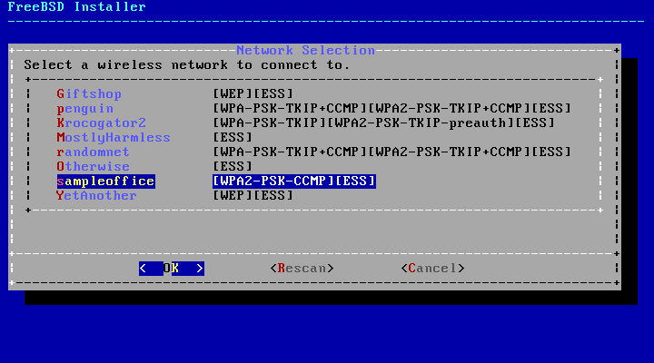

Next, enter the encryption information for connecting to the selected wireless network. WPA2 encryption is strongly recommended as older encryption types, like WEP, offer little security. If the network uses WPA2, input the password, also known as the Pre-Shared Key (PSK). For security reasons, the characters typed into the input box are displayed as asterisks.
Figure 2.34. WPA2 Setup
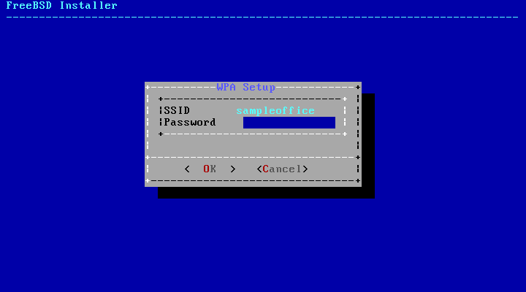

Next, choose whether or not an IPv4 address should be configured on the Ethernet or wireless interface:
Figure 2.35. Choose IPv4 Networking
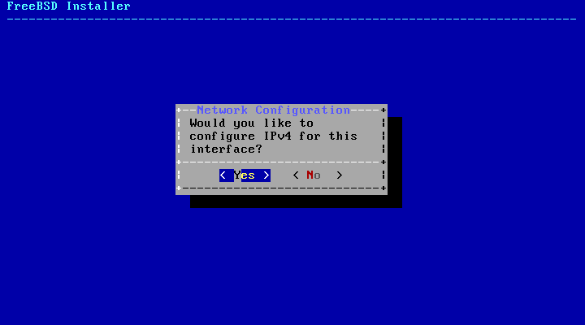

There are two methods of IPv4 configuration. DHCP will automatically configure the network interface correctly and should be used if the network provides a DHCP server. Otherwise, the addressing information needs to be input manually as a static configuration.

Note:
Do not enter random network information as it will not work. If a DHCP server is not available, obtain the information listed in Required Network Information from the network administrator or Internet service provider.
If a DHCP server is available, select [ Yes ] in the next menu to automatically configure the network interface. The installer will appear to pause for a minute or so as it finds the DHCP server and obtains the addressing information for the system.
Figure 2.36. Choose IPv4 DHCP Configuration
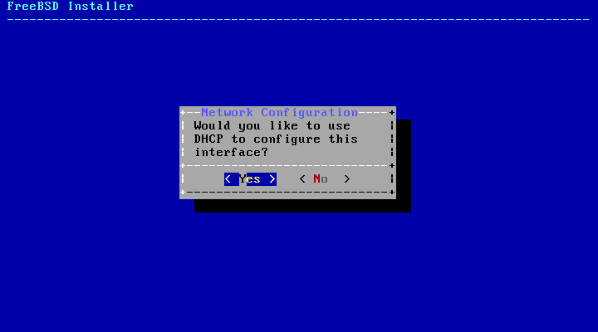

If a DHCP server is not available, select [ No ] and input the following addressing information in this menu:
Figure 2.37. IPv4 Static Configuration
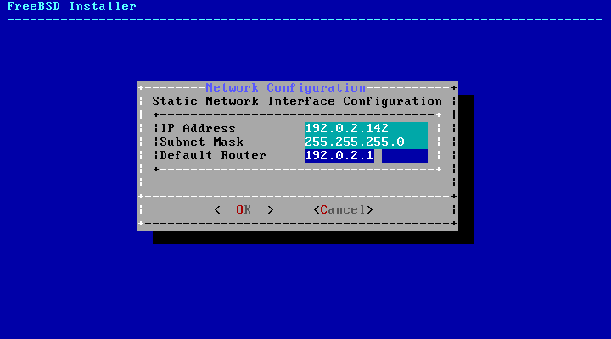

- IP Address - The IPv4 address assigned to this computer. The address must be unique and not already in use by another piece of equipment on the local network.
- Subnet Mask - The subnet mask for the network.
- Default Router - The IP address of the network's default gateway.
The next screen will ask if the interface should be configured for IPv6. If IPv6 is available and desired, choose [ Yes ] to select it.
Figure 2.38. Choose IPv6 Networking
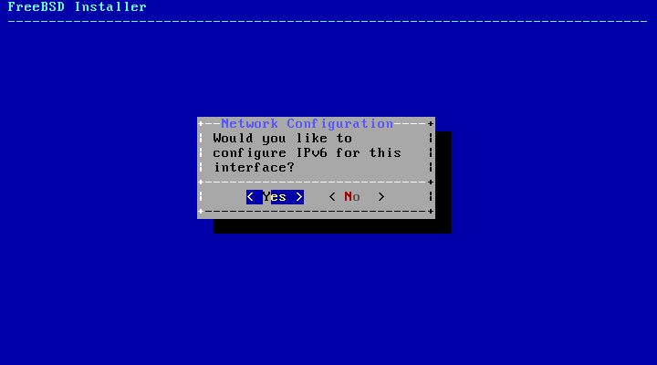

IPv6 also has two methods of configuration. StateLess Address AutoConfiguration (SLAAC) will automatically request the correct configuration information from a local router. Refer to http://tools.ietf.org/html/rfc4862 for more information. Static configuration requires manual entry of network information.
If an IPv6 router is available, select [ Yes ] in the next menu to automatically configure the network interface. The installer will appear to pause for a minute or so as it finds the router and obtains the addressing information for the system.
Figure 2.39. Choose IPv6 SLAAC Configuration
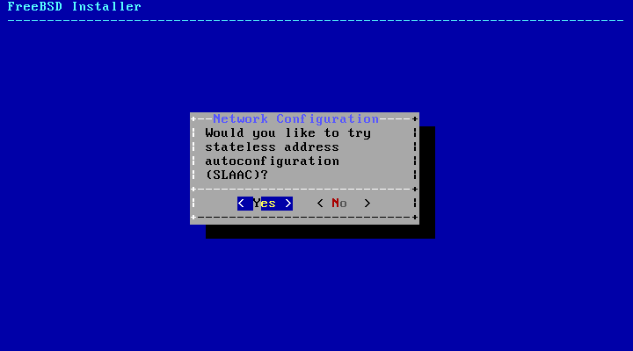

If an IPv6 router is not available, select [ No ] and input the following addressing information in this menu:
Figure 2.40. IPv6 Static Configuration
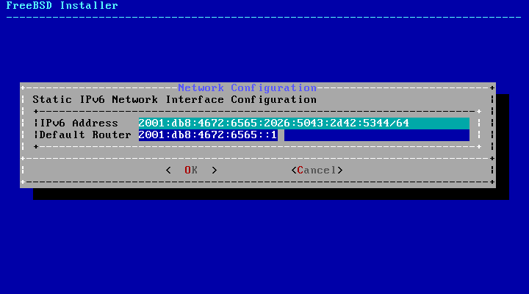

- IPv6 Address - The IPv6 address assigned to this computer. The address must be unique and not already in use by another piece of equipment on the local network.
- Default Router - The IPv6 address of the network's default gateway.
The last network configuration menu is used to configure the Domain Name System (DNS) resolver, which converts hostnames to and from network addresses. If DHCP or SLAAC was used to autoconfigure the network interface, the Resolver Configuration values may already be filled in. Otherwise, enter the local network's domain name in the Search field. DNS #1 and DNS #2 are the IPv4 and/or IPv6 addresses of the DNS servers. At least one DNS server is required.
Figure 2.41. DNS Configuration
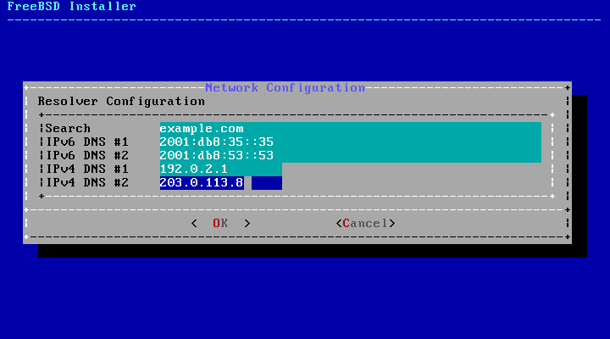

2.8.3. Setting the Time Zone
The next menu asks if the system clock uses UTC or local time. When in doubt, select [ No ] to choose the more commonly-used local time.
Figure 2.42. Select Local or UTC Clock
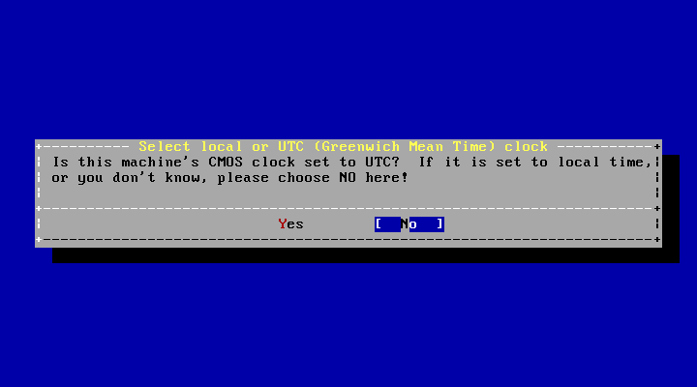

The next series of menus are used to determine the correct local time by selecting the geographic region, country, and time zone. Setting the time zone allows the system to automatically correct for regional time changes, such as daylight savings time, and perform other time zone related functions properly.
The example shown here is for a machine located in the Eastern time zone of the United States. The selections will vary according to the geographical location.
Figure 2.43. Select a Region
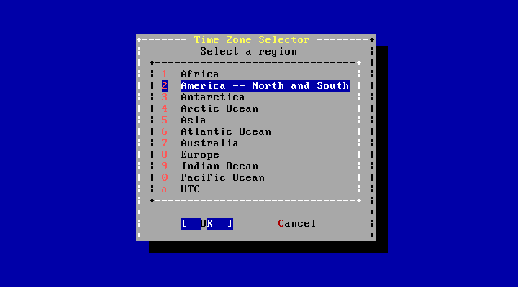

The appropriate region is selected using the arrow keys and then pressing Enter.
Figure 2.44. Select a Country
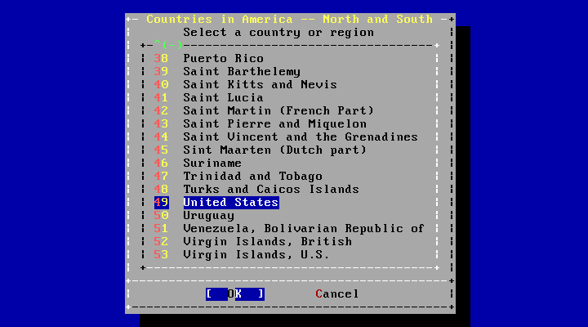

Select the appropriate country using the arrow keys and press Enter.
Figure 2.45. Select a Time Zone
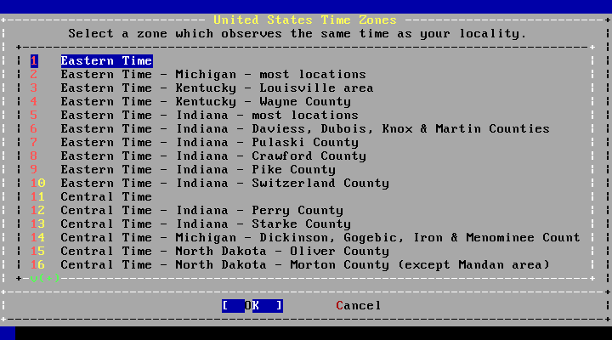

The appropriate time zone is selected using the arrow keys and pressing Enter.
Figure 2.46. Confirm Time Zone
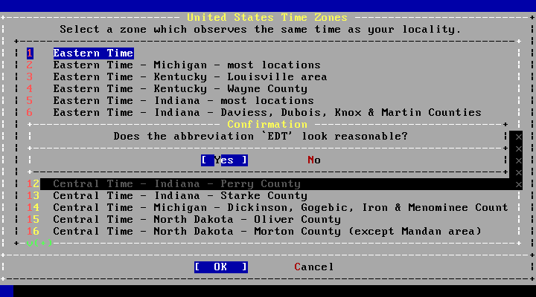

Confirm the abbreviation for the time zone is correct. If it is, press Enter to continue with the post-installation configuration.

2.8.4. Enabling Services
The next menu is used to configure which system services will be started whenever the system boots. All of these services are optional. Only start the services that are needed for the system to function.
Figure 2.47. Selecting Additional Services to Enable
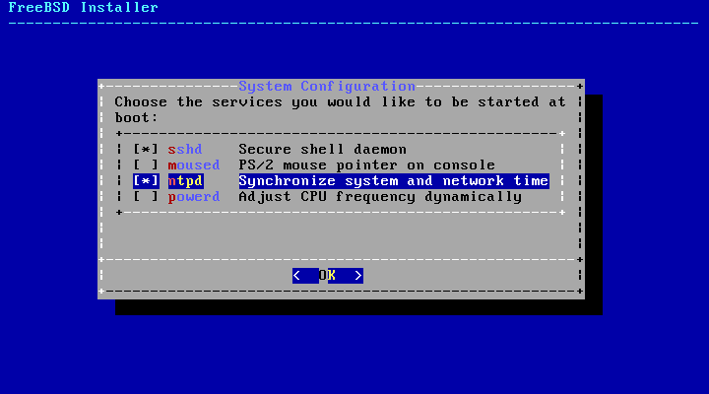

Here is a summary of the services which can be enabled in this menu:
- sshd - The Secure Shell (SSH) daemon is used to remotely access a system over an encrypted connection. Only enable this service if the system should be available for remote logins.
- moused - Enable this service if the mouse will be used from the command-line system console.
- ntpd - The Network Time Protocol (NTP) daemon for automatic clock synchronization. Enable this service if there is a Windows®, Kerberos, or LDAP server on the network.
- powerd - System power control utility for power control and energy saving.

2.8.5. Enabling Crash Dumps
The next menu is used to configure whether or not crash dumps should be enabled. Enabling crash dumps can be useful in debugging issues with the system, so users are encouraged to enable crash dumps.
Figure 2.48. Enabling Crash Dumps
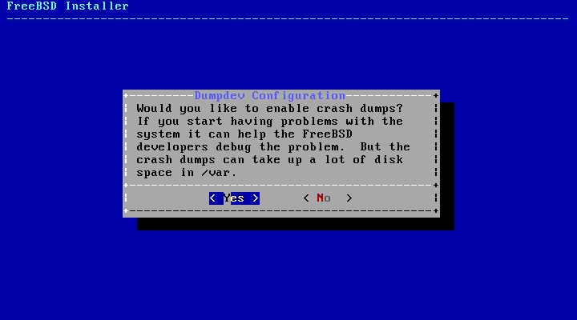

2.8.6. Add Users
The next menu prompts to create at least one user account. It is recommended to login to the system using a user account rather than as root. When logged in as root, there are essentially no limits or protection on what can be done. Logging in as a normal user is safer and more secure.
Select [ Yes ] to add new users.
Figure 2.49. Add User Accounts
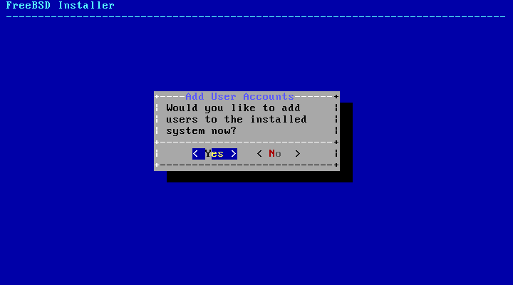

Follow the prompts and input the requested information for the user account. The example shown in Figure 2.50, “Enter User Information” creates the asample user account.
Figure 2.50. Enter User Information
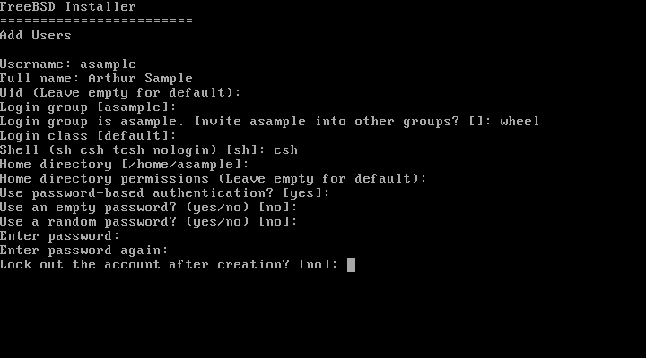

Here is a summary of the information to input:
- Username - The name the user will enter to log in. A common convention is to use the first letter of the first name combined with the last name, as long as each username is unique for the system. The username is case sensitive and should not contain any spaces.
- Full name - The user's full name. This can contain spaces and is used as a description for the user account.
- Uid - User ID. Typically, this is left blank so the system will assign a value.
- Login group - The user's group. Typically this is left blank to accept the default.
- Invite user into other groups? - Additional groups to which the user will be added as a member. If the user needs administrative access, type wheel here.
- Login class - Typically left blank for the default.
- Shell - Type in one of the listed values to set the interactive shell for the user. Refer to Section 3.9, “Shells” for more information about shells.
- Home directory - The user's home directory. The default is usually correct.
- Home directory permissions - Permissions on the user's home directory. The default is usually correct.
- Use password-based authentication? - Typically yes so that the user is prompted to input their password at login.
- Use an empty password? - Typically no as it is insecure to have a blank password.
- Use a random password? - Typically no so that the user can set their own password in the next prompt.
- Enter password - The password for this user. Characters typed will not show on the screen.
- Enter password again - The password must be typed again for verification.
- Lock out the account after creation? - Typically no so that the user can login.
After entering everything, a summary is shown for review. If a mistake was made, enter no and try again. If everything is correct, enter yes to create the new user.
Figure 2.51. Exit User and Group Management
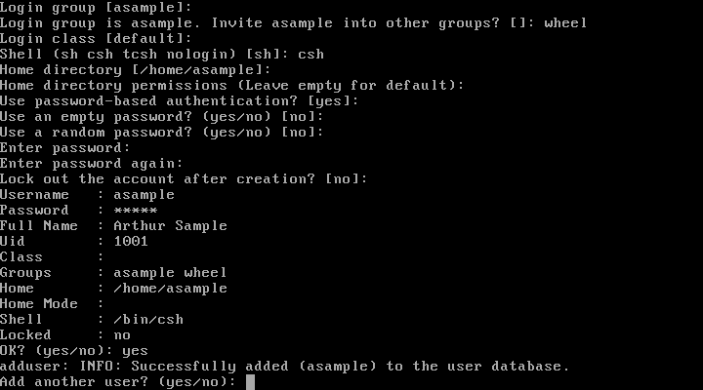

If there are more users to add, answer the Add another user? question with yes. Enter no to finish adding users and continue the installation.
For more information on adding users and user management, see Section 3.3, “Users and Basic Account Management”.

2.8.7. Final Configuration
After everything has been installed and configured, a final chance is provided to modify settings.
Figure 2.52. Final Configuration
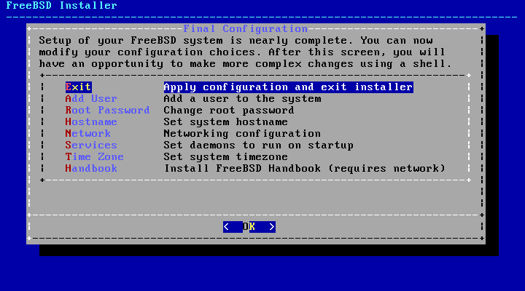

Use this menu to make any changes or do any additional configuration before completing the installation.
- Add User - Described in Section 2.8.6, “Add Users”.
- Root Password - Described in Section 2.8.1, “Setting the root Password”.
- Hostname - Described in Section 2.5.2, “Setting the Hostname”.
- Network - Described in Section 2.8.2, “Configuring Network Interfaces”.
- Services - Described in Section 2.8.4, “Enabling Services”.
- Time Zone - Described in Section 2.8.3, “Setting the Time Zone”.
- Handbook - Download and install the FreeBSD Handbook.
After any final configuration is complete, select Exit.
Figure 2.53. Manual Configuration
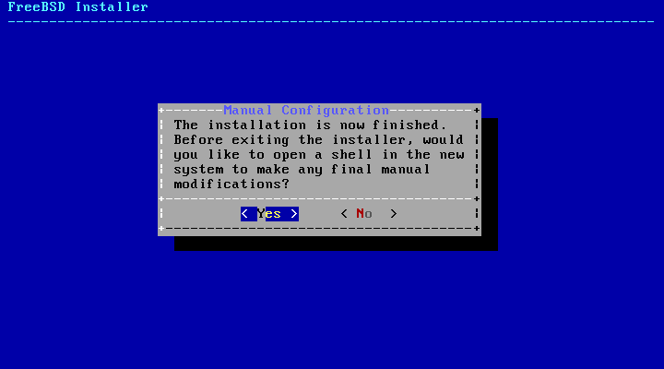

bsdinstall will prompt if there are any additional configuration that needs to be done before rebooting into the new system. Select [ Yes ] to exit to a shell within the new system or [ No ] to proceed to the last step of the installation.
Figure 2.54. Complete the Installation
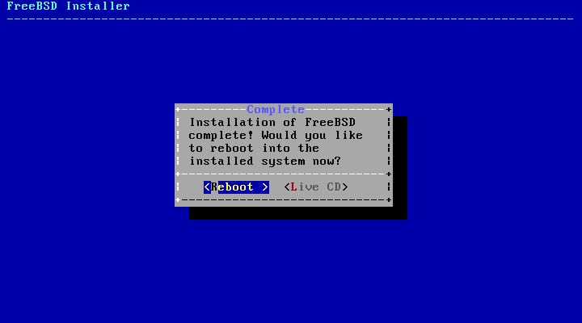

If further configuration or special setup is needed, select [ Live CD ] to boot the install media into Live CD mode.
If the installation is complete, select [ Reboot ] to reboot the computer and start the new FreeBSD system. Do not forget to remove the FreeBSD install media or the computer may boot from it again.
As FreeBSD boots, informational messages are displayed. After the system finishes booting, a login prompt is displayed. At the login: prompt, enter the username added during the installation. Avoid logging in as root. Refer to Section 3.3.1.3, “The Superuser Account” for instructions on how to become the superuser when administrative access is needed.
The messages that appeared during boot can be reviewed by pressing Scroll-Lock to turn on the scroll-back buffer. The PgUp, PgDn, and arrow keys can be used to scroll back through the messages. When finished, press Scroll-Lock again to unlock the display and return to the console. To review these messages once the system has been up for some time, type less /var/run/dmesg.boot from a command prompt. Press q to return to the command line after viewing.
If sshd was enabled in Figure 2.47, “Selecting Additional Services to Enable”, the first boot may be a bit slower as the system will generate the RSA and DSA keys. Subsequent boots will be faster. The fingerprints of the keys will be displayed, as seen in this example:
Generating public/private rsa1 key pair.
Your identification has been saved in /etc/ssh/ssh_host_key.
Your public key has been saved in /etc/ssh/ssh_host_key.pub.
The key fingerprint is:
10:a0:f5:af:93:ae:a3:1a:b2:bb:3c:35:d9:5a:b3:f3 root@machine3.example.com
The key's randomart image is:
+--[RSA1 1024]----+
| o.. |
| o . . |
| . o |
| o |
| o S |
| + + o |
|o . + * |
|o+ ..+ . |
|==o..o+E |
+-----------------+
Generating public/private dsa key pair.
Your identification has been saved in /etc/ssh/ssh_host_dsa_key.
Your public key has been saved in /etc/ssh/ssh_host_dsa_key.pub.
The key fingerprint is:
7e:1c:ce:dc:8a:3a:18:13:5b:34:b5:cf:d9:d1:47:b2 root@machine3.example.com
The key's randomart image is:
+--[ DSA 1024]----+
| .. . .|
| o . . + |
| . .. . E .|
| . . o o . . |
| + S = . |
| + . = o |
| + . * . |
| . . o . |
| .o. . |
+-----------------+
Starting sshd.
Refer to Section 13.8, “OpenSSH” for more information about fingerprints and SSH.
FreeBSD does not install a graphical environment by default. Refer to Chapter 5, The X Window System for more information about installing and configuring a graphical window manager.
Proper shutdown of a FreeBSD computer helps protect data and hardware from damage. Do not turn off the power before the system has been properly shut down! If the user is a member of the wheel group, become the superuser by typing su at the command line and entering the root password. Then, type shutdown -p now and the system will shut down cleanly, and if the hardware supports it, turn itself off.

Troubleshooting
This section covers basic installation troubleshooting, such as common problems people have reported.
Check the Hardware Notes (https://www.freebsd.org/releases/index.html) document for the version of FreeBSD to make sure the hardware is supported. If the hardware is supported and lock-ups or other problems occur, build a custom kernel using the instructions in Chapter 8, Configuring the FreeBSD Kernel to add support for devices which are not present in the GENERIC kernel. The default kernel assumes that most hardware devices are in their factory default configuration in terms of IRQs, I/O addresses, and DMA channels. If the hardware has been reconfigured, a custom kernel configuration file can tell FreeBSD where to find things.

Note:
Some installation problems can be avoided or alleviated by updating the firmware on various hardware components, most notably the motherboard. Motherboard firmware is usually referred to as the BIOS. Most motherboard and computer manufacturers have a website for upgrades and upgrade information.
Manufacturers generally advise against upgrading the motherboard BIOS unless there is a good reason for doing so, like a critical update. The upgrade process can go wrong, leaving the BIOS incomplete and the computer inoperative.
If the system hangs while probing hardware during boot, or it behaves strangely during install, ACPI may be the culprit. FreeBSD makes extensive use of the system ACPI service on the i386, amd64, and ia64 platforms to aid in system configuration if it is detected during boot. Unfortunately, some bugs still exist in both the ACPI driver and within system motherboards and BIOS firmware. ACPI can be disabled by setting the hint.acpi.0.disabled hint in the third stage boot loader:
set hint.acpi.0.disabled="1"
This is reset each time the system is booted, so it is necessary to add hint.acpi.0.disabled="1" to the file /boot/loader.conf. More information about the boot loader can be found in Section 12.1, “Synopsis”.

Using the Live CD
The welcome menu of bsdinstall, shown in Figure 2.3, “Welcome Menu”, provides a [ Live CD ] option. This is useful for those who are still wondering whether FreeBSD is the right operating system for them and want to test some of the features before installing.
The following points should be noted before using the [ Live CD ]:
- To gain access to the system, authentication is required. The username is root and the password is blank.
- As the system runs directly from the installation media, performance will be significantly slower than that of a system installed on a hard disk.
- This option only provides a command prompt and not a graphical interface.

FreeBSD Basics

https://www.freebsd.org/doc/en_US.ISO8859-1/books/handbook/basics.html

